Teaching a Bible verse using the IPEAR method

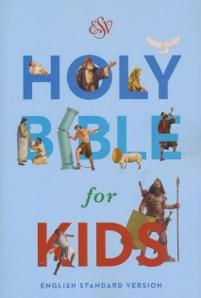

I Introduce the verse. Needs to be brief and can be a question, object lesson or short story.
P Present the verse in the Bible. Read directly from the Bible and explain the Bible is God’s true Word.
E Explain words and concepts in the verse children might not know or understand.
A Apply to their life according to what the verse is saying. Application should be to both the saved and the unsaved child.
For saved children it could be a truth to grab hold of, command to obey or something to help him grow.
For unsaved children the application points to need for salvation.
R Repeat the verse 8 – 10 times in a fun way.

