Good News Club Theme and Active Games
Jesus God Who Cares for People
The theme and game should be done in 10 minutes or less for a 60-minute club. For a 90-minute club it can be done in 15-20 minutes. The theme ideas can be shared in the lesson and even at the end the club. The theme and games are a great way to use fun to reenforce the message. It can also help the kids stay focused. In the five week lesson series the children will see how each lesson connects. The theme will help reinforce the message.

God’s love and care is real. There is no magic or illusions:
Who really cares about you? Sometimes it might be hard to know who cares about you. People can act like they care. Jesus cares about you. He cares for all people. Through His words and actions, He has proven His love for all people.
This series children will see clearly how much Jesus cares for them.
There are no tricks and illusions. Everything Jesus does is real. His love for people is real and there is nothing fake about it. The children will see Jesus as God who cares for them. This will give them a true sense of value and purpose. They will be compelled to show the same love and care to others.
Supplies:
Lesson 1
- Several small balls (Active Game)
- Word strips “Jesus is God who cares for people” # 1-7 on back of word strips. (Lesson Intro)
- White board or poster paper (Lesson Intro)
- Milk jug with grape juice (Lesson illustration)
- “Sentence matchup” Word strip (Review Game)

Lesson 2
- Picture of police, fireman, magician, football player (Word Up)
- Sign “Good Person” (Word Up)
- 20-30 Small items and a cloth (Active Game)
- “I a good person” Skit card (Lesson Intro)
- Dead plant (Memory Verse Intro)
- John 3:16 Word Strips (Memory Verse Review)
- 12 months of the year on cards (Review Game)

Lesson 3
- Globe or map of the world (Word Up)
- “Jesus Loves Everyone” Written on paper (2-3 sets)
(Active Game)
- Signs of Judea, Samaria, and Galilee (Lesson Into)
- Sticky notes (Memory Verse Review)
- Give or Take cards with points values (Review Game)

Lesson 4
- Promise written on dry erase board (Word Up)
“I think we will have ice cream after school today.”
“We will not have ice cream today.”
“I promise we will have ice cream after school.”
- 10 Images of a real and a fake object – or the object
(Apple, Car, Coin, Grapes, Paper money, iPhone)
(Active Game)
1. You will have an easy life. 2. God will never allow you to get sick. 3. God will give you everything you want 4. God promises to love you. 5. You will have strength in hard times. 6. God gives eternal life to those who trust in Jesus.
(Memory Verse Intro)
- God Cares Card: "Sad, Anger, Afraid, Worried, Hurt, Sick, Happy, Surprised and Confused. (Review Game)
- Bag with the sentence “Times God Cares for Children”
(Review Game)

Lesson 5
- Dry erase board (Word Up)
- 3 sets of the word “Mercy” 3 separate colors (Active Game)
- Choices in life written on cards (Memory Verse Intro)
- Word from the verse written on cards (Memory Verse)
- Blind fold - A few small objects (Lesson Intro)
- “Find Bartimaeus Puzzle Game” Game pieces placed in bag with title of game written on bag (Review Game Option)

Jesus: God Who Cares for People Lesson 1
Jesus Shows He is the Almighty God (John 2:1-11)

Word Up: "Jesus is the almighty God!"
Who is the strongest in this room? Who can jump the highest? Who can run the fastest? Who is the best at math? Who has the best memory? (Resp) Jesus has power, wisdom, knowledge in everything! He has all power because He is God. We will learn how powerful Jesus is. "Jesus is the almighty God!" He cares for you! How does that make you feel?

Active Game: "Musical Ball Pass” (Have the children stand in a circle, or they can sit in chairs. Pass a small ball or several balls around while music is playing. When the music stops the children holding the ball(s) must yell out the Word Up “Jesus is the almighty God!

Memory Verse: John 3:16
Introduction- What do you love most? (Resp) What does God love most?
Presentation-Read from Bible while kids follow in visual.
Application-(Unsaved) God loves you. Believe on Him.
(Saved) Praise Him of saving you.
Repetition- "Whoever” Have kids stand when the phrase or word "the world" and "whoever" appear in this verse. (Whoever cards)
“Hot & Cold Verse” Hide the word “The World” and “Whoever”. One student must look for the two words as the class yells when they are close and say the verse quietly when they are far away.

Review Game: "Sentence Match-Up"
Cards are placed down with numbers 1-6 on one side and part of a sentence on the other. Choose two or three teams. After each correct answer teams pick two cards to make a complete sentence. Award points or candy for correct answers and making a sentence

Jesus is God Who Cares for People Lesson 2
Nicodemus Can't Save Himself (John 3:1-16)

Word Up: "Jesus gives new life!"
Show pictures of a police officer, fireman, magician, football player. If I put on these uniforms would that make me one of them? (Resp) What if I try hard at being good. Would that make God love me? (Sign Good Person) (Response) Only Jesus can forgive you of your sins and give you a new life! Jesus gives new life! Jesus was helping the man know He was loved and there was nothing he could do to earn it. Accept His love.

Active Game: “What is missing?” Place 20-30 small objects on a table. Cover the items with a cloth. Divide the class into two teams. The teams have 30 seconds to memorize the items. Without the class looking take 1-2 items off the table. The team that can guess which items are missing get a candy and 100 points. The team with the most points wins. To speed the game along give the teams a 15-20 second countdown for each guess.

Memory Verse: John 3 :16
Introduction- (Show children a dead plant) I have done everything to make it grow. Can I really make it grow? (Attempt to speak to the plant) Who alone can give life? (Response) (Read verse)
Presentation- Read from Bible.
Application- (Unsaved) Jesus is perfect. He kept all God’s law. Only Jesus can give you new life. You can believe in Him today.
(Saved) If you have believed Jesus is the only Savior God can change your heart! You already have the joy and blessings of everlasting life! God gives you the Holy Spirit!
Repetition- “Unscramble” (put the words or phrases of Jn. 3:16 on strips of paper, spread them on table. Pick children to put word in right order.)

Review Game: “Birthday Points”
Divide into two teams. The 12 months of the year on cards. After each correct answer a child picks a month and gets 100 points for each letter in the word. They get an additional 100 points for each person with a birthday in that month.

Jesus: God Who Cares for People Lesson 3
Jesus Loves Everyone (John 4:1-30, 39-42)

Word Up: "Jesus loves everyone!"
Close your eyes and think of a person you love. Jesus loves everyone in the entire world. Or (Show the globe or map of the world) Jesus loves all people in the world. (Spin the globe or point on the map).
He loves people in every country. Will you show God’s love to everyone like Jesus did? God will help you love others.

Active Game: “Hide the words” “Jesus loves everyone” around the room. Divide into two or three teams and have the teams circle around a table. When music starts teams must find the words and put them in a sentence at their table. The first person to put it together and yell the phrase wins.
Alternative: Before the game teachers can write the team members names on separate papers. They must find their names to win.

Memory Verse John 3:17
Introduction- Can you think of a time when someone found out you did something wrong? (Share example) There are punishments to keep us from doing it again. Jesus was perfect. Why did Jesus come into the world? (Response)
Presentation- Read John 3:17 Why did God send His son? (Response)
Application- (Unsaved) Jesus came to show His love to you. Will you believe?
(Saved) He came to show us how to care for others. He wants you to love all people by telling them of God's love and praying they will trust Him.
Repetition- "Stump the Teacher"
(Blindfold a teacher. Allow kids to cover a word from the verse with a sticky note. Lead kids in saying the verse, skip the covered word. Blindfolded teacher guesses the word. Continue by covering more words.)

Review Game: "Give or Take"
(Divide into two teams. Place cards with Give or Take face down or put them in a bag. After each correct answer teams pick a card. Have point values on the back of each card. They must give it to the other team or take if for their own. The team with the most points wins.)

Jesus God Who Cares for People Lesson 4
Jesus Heals the Nobleman's Son (John 4:46-54)

Word Up: "Believe God's promise!"
Which do you like better? (Write on dry erase board or paper)
“I think we will have ice cream after school today.”
“We will not have ice cream today.” “I promise we will have ice cream after school.” Why do you like the last one. (Resp) We don't always keep our promises but who does keep their promise always? (Resp)
We can trust God to keep His promises. This is another way God proves He cares for us. He shows us He is real, & He loves us. He keeps His promises.

Active Game: “God Promises are Real not Fake”
Divide class into 2 teams. Give teams a different colored sticky note or clothes pin. Show items or have pictures of something fake and something real. (Example “fake apple and real apple,” “Toy car and real car,” “fake coin and real coin”). Teams line up. One team member at a time runs to a table where the objects or pictures are placed. They place their sticky note next to the item they believe to be real. The team with the most correct guesses is the winner. Explain: We may not always know what is real but one person we can trust all the time is God. He keeps His promises.

Memory Verse: John 3:36
Introduction- (Show promises of God and what people think are God’s promises. Have class guess which ones are real promises).
1. You will have an easy life. 2. God will never allow you to get sick. 3. God will give you everything you want 4. God promises to love you. 5. You will have strength in hard times. 6. God gives eternal life to those who trust in Jesus. (Response) What promises are in this verse? (Response)
Alternative- Make a promise to a child. "I promise I will give you this candy after class." What if after class I forgot? Would I be keeping my promise? (Response) God always keeps His promises! Everything He says true!
Our verse tells us something God promises will happen. What is it! (Response)
Presentation- (Read John 3:36) Show books of the Bible Poster.
Explanation- Explain hard words and concepts.
Application- (Unsaved) This promise is for you but what must you do first? (Response) Will you believe today? (Saved) God kept His promise. If we believe in Jesus we are not separated from God. Spend time reading God's Word so you can find other promises. He keeps promises.
Repetition- "Crazy Phrases" Divide into three or four teams. Assign each group a section of the verse. Point to one group at a time to recite their section.

Review Game: "God Cares When... Charades"
(Write these words on cards-"Sad, Anger, Afraid, Worried, Hurt, Sick, Happy." Etc. Write this sentence on a bag “Times God cares for children.”. When a child answers a question correctly his team gets 1,000 points. Have them pull from bag one of the words. The team can act out or make an expression of the sentence. If the other team guess the expression correctly give the team an extra 1,000 points.)

Jesus God Who Cares for People Lesson 5
Jesus Cares for Bartimaeus (Mark 10:46-52; Luke 18:35-43)

Word Up: “Praise God for His mercy”
On a dry erase board make two columns. In the first column write down sins (stealing, disobeying, lying, fighting, etc.). In the second write the word punishment. Jesus took our punishment. What is my response? What do I say to God? (Resp) How do I thank Him? Telling God how good He is called praising Him. What can you praise Him for? (Resp) (Write on board)
Jesus sacrificing His life to save yours is how He shows how much He cares for you. Telling God brings Him joy and you will have more joy as you remember what He has done. Praise God every day!

Active Game “Find God’s Mercy” (Hide two or three sets of the letters in the word MERCY around the room. Divide class into two or three teams and assign each team a color Blue, Red, Green &

Memory Verse: John 3:36 “Whoever believes in the Son has eternal life; whoever does not obey the Son shall not see life, but the wrath of God remains on him.”
Introduction- We all have choices to make every day. (Have children give a few examples of choices they made that day).
What job you will choose? 2. Where will you live? 3. Where will you go to school. What car will you buy? Who will be your friends? Will you get married? There is one choice that is most important.

Presentation- Where is this verse found? Read from Bible.
Explanation- Application- (Saved) You can praise God for His mercy. Thank Him for new life. (Unsaved) You can trust Jesus to forgive your sins.
Repetition- “Erase a word.” “Verse Scramble.”
Purple. When the music starts teams must find their letters. The team who puts the letters together in the right order first and yells the word is the winner.)

Lesson Activity: (Older Kids) Place the older kids into teams of 3 or 4. Give them a piece of paper and have them come up with a definition for “Mercy” Talk about the meaning of the word with them.
(Younger Kids) On a piece of paper write the word “Mercy”. On pieces of paper have definition of other words. On a strip of paper have a simple definition of mercy. Kids must guess which definition is the correct one.
Review Game: “Find Bartimaeus Puzzle Game”
(Divide class into two or three teams. After each correct answer the one who answers gets a candy. They then choose two cards from a bag. They must do what is written on the card. They put the card picture side up on a table. The team who completes the puzzle first is the winner.)
“I Spy Points” (Choose a mystery object. Tell children what color it is or what letter it starts with. When a child answers correctly award 1,000 points to his team. That team gets to guess the mystery object. If he guesses right, they get 1,000 points.).

Jesus
is God
people
for
cares
who
Jesus is God

for people
who cares






Jesus did things
Jesus loves you and me
People are

Lesson 1 Sentence match up
only God could do.
Jesus is the Savior who
God promised to send.
Jesus told the servant to
God spoke through
God’s most special creation.
very much.
men called prophets.
fill the jars with water.
Lesson 2 Review Game “Birthday points”
December
November
October
September
August
July
June
May
April
January
February
March
Give
5,000 points
Give
5,000 points
Give
5,000 points

Give
10,000 points
Give
10,000 points
Give
10,000 points

Give
25,000 points
Give
25,000 points
Give
25,000 points

Give
50,000 points
Give
50,000 points
Give
50,000 points

Lesson 3 “Give or Take”
Take
5,000 points
Take
5,000 points
Take
5,000 points
Lesson 3 “Give or Take”
Take
50,000 points
Take
50,000 points
Take
50,000 points
Take
25,000 points
Take
25,000 points
Take
25,000 points
Take
10,000 points
Take
10,000 points
Take
10,000 points
Jesus
loves
Jesus
Lesson 3 Active Game “Hide the Words”
Everyone
Everyone
loves
loves
Jesus
Everyone
Sick
Hurt
Surprised
Lesson 4 Review Game God Cares Charades
Confused
Worried
Sad
Happy
Afraid
Lost
Hungry
Angry
M
M
M
C
C
C
R
R
R
E
E
E
Y
Mercy
Mercy
Lesson 5 Active Game “Find God’s Mercy”
Y
Y
eternal life
in the Son has
“Whoever believes

whoever does not obey
but the wrath of God
the son shall not see life
John 3:36
remains on him.”
Lesson 5 Memory Verse
that whoever believes
gave his only Son,
the world that he
“For God so loved
perish but have
in him should not
eternal life.”
Lesson 1-2 Memory Verse
John 3:16
Lesson 3 Bible Lesson
Samaria
Judea
Galilee
1. You will have an easy life.
2. God will never allow you to get sick.
3. God will give you everything you want.
4. God promises to love you.
5. You will have strength in hard times.
6. God gives eternal life to those who trust in Jesus.

Lesson 4 Memory Verse Introduction
1. You will have an easy life.
2. God will never allow you to get sick.
3. God will give you everything you want.
4. God promises to love you.
5. You will have strength in hard times.
6. God gives eternal life to those who trust in Jesus.
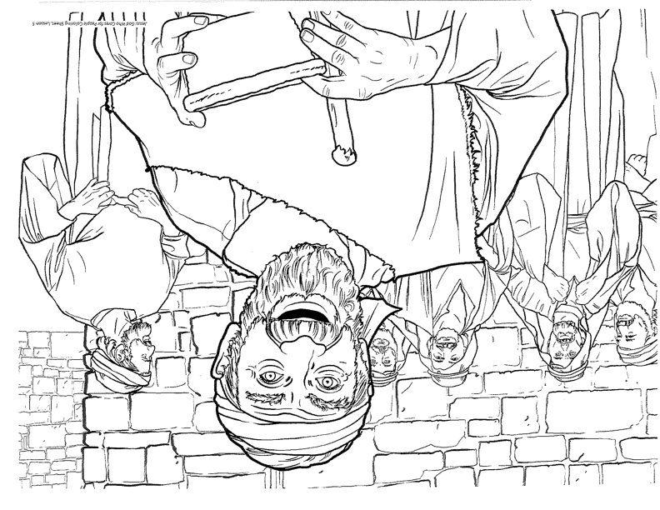
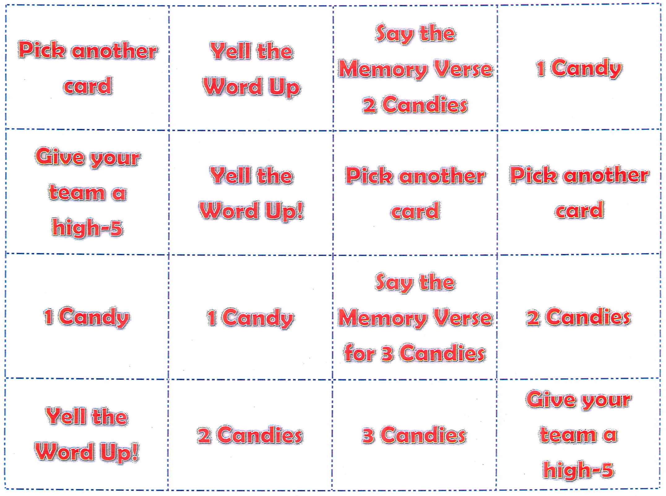
Lesson 5 Review Game Print image and card back to back.

